Every Child Belongs

Resource Consultation Service

Individual Goals & Strategies

Child's Initials  M. | Service Request Number | Agency File Number | Today's Date (yyyy-mm-dd)
Child Care/Home Child Care Program Name: |  | Location Identification Number | Review Date (yyyy-mm-dd)

Developmental Domain(s)
Social | Emotional | Physical (Motor) | Communication | Cognition | self-Help

Activity/Time of Day
Free Play | Arrival | Outdoor Play | Circle | Washroom | Mealtime | Departure Other _____

Long Term Goal(s)
- M. will improve his communication skills by using words.
- M. will improve self dressing skills.
- M. will be using utensils to self feed.
- M. will improve his fine motor skills.
- M. will be potty trained.
- M. will improve his social and emotional skills.

Short Term Objective(s)
- M will communicate his needs/wants 5 times a day
- M. will use 5 new words in two weeks
- M. will practice dressing himself at least once a day.
- M. will be reminded to use utensils to self-feed at least two times a day.
- M. will practice his fine motor skills at least once a day through fine motor activity.
- M. will be sitting on the potty at least 3 times a day. Once in the morning, once after lunch and once after snack time.
- M. will observe and follow visual/auditory cues for tasks and transitions, at least twice a day.
- M. will engage in small group play for at least 15 minutes each day

Strategies/Adaptations

COMMUNICATION:
- Use short descriptive phrases and sentences.

- Ask Choice questions, for example “Do you want a ___ or ___?”

- Model what M. should be saying instead of telling him or asking him. For example, Say “want cup” and Don’t say: “Say ‘want cup’”. Don’t say:” Want cup?” because he will just answer “yes” or “no”

- Label by naming objects, actions, locations and description of what M. is interested in. Describe what M. is doing and what you are doing. For example, when you are doing pretend play with M., say “M. is putting an egg into the pot. Now let me turn on the stove.”

- Repeat the proper pronunciation of words back to M.

- Choose books that are suitable to M.’s language level and repeat the same book for each week. (eg. The Very Hungry Caterpillar, Brown Bear, Brown Bear, What Do You See? Moo, Baa, La La La!) Once M. is very familiar with the content, purposely leave out some words while reading and let M. fill in the words.

Check this list for a list of books recommended:
https://www.goodreads.com/list/show/838.Books_for_two_year_old_children

- Similar to the above strategy, choose a couple of songs to sing for M. for the week. Repeat them everyday to M. When he is familiar with the song, leave out a word from the song for him to complete. Check out the song list suitable for toddlers and preschoolers.

https://www.thebump.com/a/nursery-rhymes

- Use Communication Temptations: Communication temptations can be used in any environment in which M. shows a need to communicate. Try not to anticipate M.’s needs, instead hold off and allow him to attempt to communicate his needs.

How could you set up Communication Temptations?

• Set up a game, leaving out an important part (e.g., dice), and say “let’s play.”
• Set up a painting activity and forget to give M. a paintbrush.
• Sing M.’s favourite song and leave out a word
• When reading a book don’t turn the page until M. says “Turn page”
• While on a swing, give M. a push and then hold the swing until he says “push” or “go”

FINE MOTOR:
- Offer fine motor activities at least once a day to help M. strengthen his finger muscles.

Find the link to see more fine motor activity ideas.

https://www.littlelifelonglearners.com/2020/03/8-activities-to-develop-fine-motor-skills-at-home.html/

- Engage M. in writing and pre-writing learning opportunities like drawing/ writing using her index finger, brush, stick, popsicle stick, or chalk over sand, cornmeal, rice, paint, mud, slime, sandpaper, etc. Making a collage using letters from grocery flyers, newspapers, magazines, etc.

- Fine motor activity board.

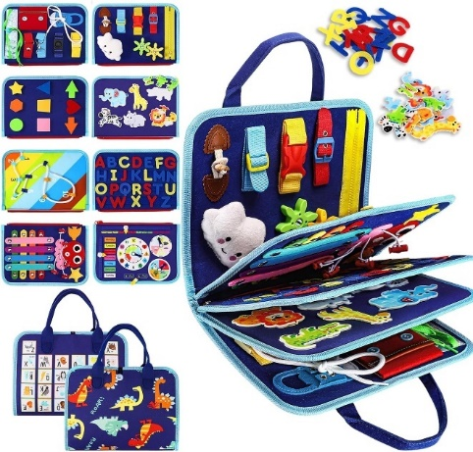

POTTY TRAINING:
- Continue to use the Toilet Training Visual Sequence in classroom and home
- Guide M. to the washroom at a regular interval (eg. 1-2 hours), one in the morning, one after lunch and one after a nap.
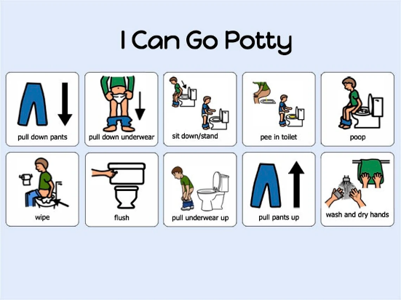

- Praise M. for every effort, eg. use a reward system such as giving out stickers for every effort M. made.

TRANSITIONS:

- Continue using a visual schedule in the classroom so M. will understand what is coming up next.
- Provide a dressing sequence visual schedule for home and school. (See attachment) Allow extra time for M. to practice dressing by himself whenever possible.

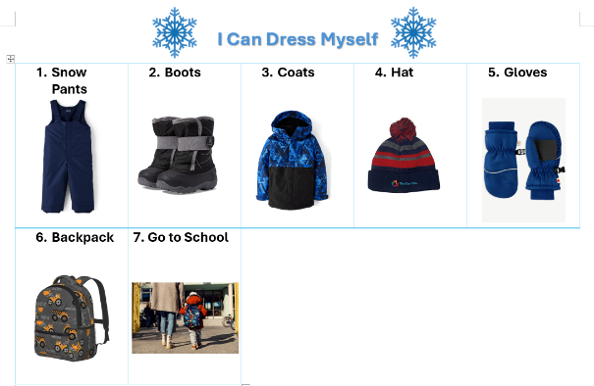

- Set up “Dress a Doll” activity for M. and other children. Help him understand what to do during dress time. (eg. put on clothes, socks, hats for a doll)

SOCIAL/EMOTIONAL:

- When M. is engaged in an activity, eg. building blocks, extend his play through conversations. For example, “I see that you are building something, what is it?” Model how to engage play with other friends by asking. Make the comment sounds very exciting such as “Wow, I see that you are building something very cool! What is it?” “Can we build together?”

- Facilitate small group play to encourage cooperative play and turn-taking skills. For example, pair the child with a peer to work on solving a puzzle together, or provide them with a picture of a structure and have them collaborate to build it using blocks. These activities promote teamwork, communication, and shared problem-solving.

Copy provided to: Parent(s)/Legal Guardian(s) Child Care/Home Child Care Program

Notice With Respect to the Collection, Use and Disclosure of Information: Personal information will be gathered by Centennial Infant and Child Centre. Any personal information collected by Centennial is collected under the authority of the Child and Family Services Act and the Personal Health Information Act (PHIPA, 2004). It will be shared only among staff of Centennial for the purpose of program planning for your child at Centennial. Questions about this collection should be directed to Barb Hannah, Executive Director, Centennial (416-935-0200 x 235).

