

Every Child Belongs
Resource Consultation Service

Consultation Summary

Child’s Name  B. |  | Date (yyyy-mm-dd)  2024-10-10 |  |  | Service Request Number |  | Agency File Number
Location: | Child Care | Virtual | School | Medical  Home |  | Home
Participants' Initial(s) and Role(s)
S. (RECE), C.(Resource Consultant)

Purpose of Visit
Observations | Screening Tool | Discuss Goals and Strategies | Meeting
Provide Resources | Coaching | Other (please specify) _______________________

Notes

B. was observed during morning indoor time including snack and indoor activities.

- B. was sitting at the table with his water bottle and snack box, waiting for an educator to provide the snack. He sat at the table and was waiting calmly. Once he got a slice of an apple, he picked up the apple using a superior pincer grasp (with his thumb and index finger). He explored the food by holding it and then putting it down before putting it into his mouth. He had a steady pace of eating.

- He seemed to be alert to his surroundings. He would keep his eyes on a peer who was crying during snack time.

- B. seemed to understand the routine with little prompts. After snack, he walked towards the sink and waited for the educator’s support to finish the hand-washing routine. He approached the carpet area when the educator was singing the “Make a Circle” song to signal it was circle time. He joined the carpet briefly then walked away and lay down on a couch near the carpet area.

- With prompts, B. was able to join the carpet area, and he refused to sit down with his peers. He was willing to sit on an educator’s lap briefly then left the circle again. He seemed more comfortable with listening and watching the circle time area from a distance.

- While the RECE was singing the song “Itsy Bitsy Spider” and purposely paused for him to finish the line, he was able to finish the line such as “wash the spider out”.

- B. was observed using pointing and one-word phrases to communicate with educators. Parents mentioned he was using 4–5-word phrases to communicate at home.

- During the pasta sensory activity, B. was reluctant to join. He was backing off when the educator showed him a cup filled with pasta. He did not seem like stickers on his shirt or hand. He peeled it off and signaled the educator to put it away while he was given one on his sweater.

- He seemed to be comfortable sitting with an educator or being close to them. When he was away from circle time, he followed an educator’s instruction to sit beside her on the stage in the classroom. He stayed in the area and moved his body up and down the stage.

- B. joined playdough activity at the table with verbal and physical prompts by an educator. He seemed to be happy while walking towards the table. He sat down and explored the playdough with pinching, pressing, and kneading movements with both hands.

- When the RC. She noticed he was sitting on the edge of the chair and helped him to sit properly. B. stared at the RC, got off his chair, and started to cry. He calmed down shortly after the educator’s comfort but did not want to continue the playdough activity.

- B. was getting ready for outdoor time by waiting at the door. He had smooth transitions throughout the morning routines.

Recommendations
- Assign one educator to work closely with B. This will help B. continue to build a sense of security and attachment. Educators are emotionally available for B. to provide emotional comfort when needed.

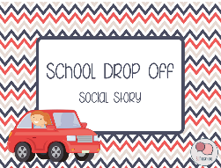
- Use a social story about dropping off at childcare to help B. to reduce separation anxiety. Please refer to the attachment called School Drop Off Social Story.

- Encourage B. to bring a comfort toy from home and/or a family photo.

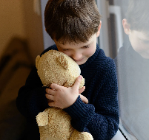

- Start the circle time with movement/action songs to gather B’s attention on the carpet. Allow movement breaks in between circle time. eg. do jumping jacks, animal moves, and have a dance party would help children to regain focus after each activity. Save these frequently used songs into a dance song list for easy access.
Suggested song list:
https://www.growinghandsonkids.com/movement-songs-for-preschoolers.html

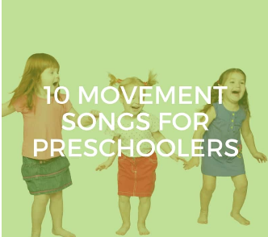
If You're Happy And You Know It
The Hokey Pokey
Head, Shoulders, Knees, and Toes
Silly Dance Contest (Jim Gill)
Shake Your Sillies Out (The Wiggles)
The Goldfish (Let's Go Swimming) (Laurie Berkner)
Run Baby Run (Caspar Babypants)
The Dinosaur Stomp (Mother Goose Playhouse Kids Song)
Rolly Polly (Mother Goose Playhouse Kids Song)
Let's Get Movin' (Lauren Meyer)

- Lay out the toys from bins and set up toys on the carpets to invite B. to play besides other children.

- Build a block tower that also include cars, and people on the carpet to encourage B. to join.
- Build part of the train tracks, including people, and houses to invite B. to continue building.

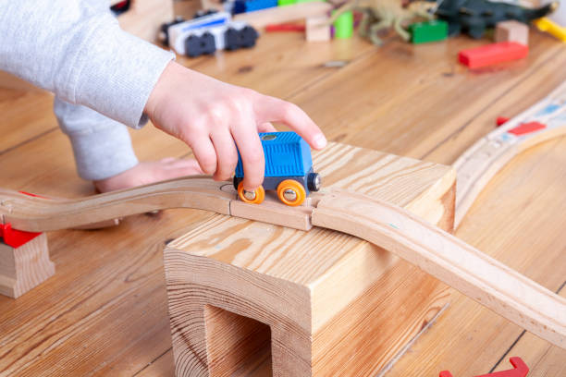
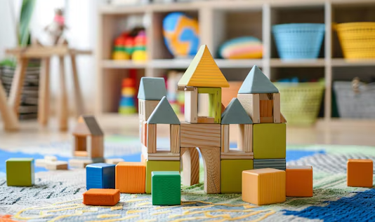

Follow-up

Resource Consultation (RC) Staff Contact Information
RC Staff Name (First and Last or Single) | Business Telephone Number
Copy Provided To: Parent(s)/Legal Guardian(s) Child Care/Home Child Care Program

Notice With Respect to the Collection, Use and Disclosure of Information: Personal information will be gathered by Centennial Infant and Child Centre. Any personal information collected by Centennial is collected under the authority of the Child and Family Services Act and the Personal Health Information Act (PHIPA, 2004). It will be shared only among staff of Centennial for the purpose of program planning for your child at Centennial

